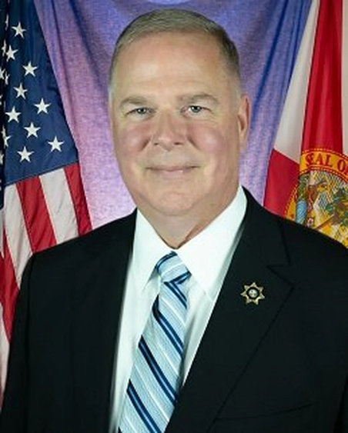
Mark S. Inch served as Florida's 12th Secretary of Corrections from January 2019 till his retirement in December 2021, following over 40 years of public service. The Florida Department of Corrections is the third largest State Corrections Agency in the Nation. He is now semi-retired and divides his time between family, ministry, and advancing the corrections profession as an author, speaker, consultant, and executive mentor.

Major General (Ret) Inch previously served as the 15th Provost Marshal General of the Army, Commanding General (CG) of the Criminal Investigation Command (CID) and Army Corrections Command, and Executive Manager of the Defense Forensics and Biometrics Agency. Serving as a Military Police Officer for 35 years and US Army Reserve Soldier for 2 years, he held other key positions including: Commanding General, Combined Joint Interagency Task Force 435 in Afghanistan, where he was responsible for Detainee Operations and Rule of Law Development within the Afghan Security Sector; Chief of the Military Police Corps Regiment/46th Commandant, U.S. Army Military Police School in Fort Leonard Wood, MO; Chief of Staff, Task Force 134 (Detainee Operations) in Iraq; 48th Commandant (Warden), U.S. Disciplinary Barracks, Fort Leavenworth, KS, and Deputy Provost Marshal, United Nations Operation in Somalia.

Following his military career and prior to joining the Florida DOC, Inch served as the 9th Director of the Federal Bureau of Prisons in 2017-2018. Director Inch oversaw the operation of 122 Bureau of Prisons' facilities with oversight of 39,000 staff and 186,000 incarcerated persons. He resigned this position due to matters of conscience.

In 1982, Inch received a Bachelor of Arts degree in Biblical Archaeology from Wheaton College, IL., in 1992, a Master of Arts in Geography (focus Middle East/Africa) from the University of Texas at Austin, and in 2005, a Master of Military Arts and Science in Military Operational Art and Science Studies from the U.S. Army Command and General Staff College. Inch completed professional certification with the American Correctional Association (ACA) and was the first association member to earn the Certified Corrections Executive designation with Honor. He received ACA's Walter Dunbar Accreditation Achievement Award in 2012 and then ACA's highest honor, the E.R. Cass Award for lifetime achievement in Corrections in 2013. Major General Inch is also a recipient of the U.S. Army Distinguished Service Medal in 2017 for exceptionally meritorious service to the Government in a duty of great responsibility.

Mr. Inch serves on the Board of Directors for the International Corrections and Prisons Association and as Chair, ACA Certification Commission. He is an Associate member with the Correctional Leaders Association and is also active with the North American Association of Wardens and Superintendents.

